Paramilitary Data

# Age

|  |  |
| --- | --- |
| 18-25 | 20 |
| 25-35 | 14 |
| 35-45 | 6 |
| 45-55 | 5 |
| 55+ | 0 |
| <18 | 1 |

# Education

|  |  |
| --- | --- |
| Basic | 1 |
| High School with Graduation | 26 |
| Secondary without GCSE | 6 |
| University | 13 |

# Income

|  |  |
| --- | --- |
| No Income (student) | 9 |
| Unemployed | 1 |
| Less than average | 4 |
| Average | 10 |
| More than average | 22 |

# Family

|  |  |
| --- | --- |
| Single | 33 |
| Married | 9 |
| Divorced with children | 1 |
| Divorced | 1 |

# Political Party Support

|  |  |
| --- | --- |
| Kotlebovci – Ľudová strana Naše Slovensko (ĽSNS) | 15 |
| Smer – sociálna demokracia | 9 |
| Vlasť | 7 |
| Obyčajní ľudia a nezávislé osobnosti (OĽaNO) | 5 |
| Sme rodina | 4 |
| Socialisti.sk | 2 |
| Kresťanskodemokratické hnutie (KDH) | 1 |
| Sloboda a Solidarita (SaS) | 1 |
| Slovenská ľudová strana Andreja Hlinku (SĽS) | 0 |
| Demokratická strana (DS) | 0 |
| Koalícia Progresívne Slovensko a Spolu | 0 |
| MÁME TOHO DOSŤ ! | 0 |
| Slovenská ľudová strana Andreja Hlinku | 0 |
| Most-Híd | 0 |
| Dobrá voľba | 0 |
| Slovenské hnutie obrody (SHO) | 0 |
| Za ľudí | 0 |
| Maďarská komunitná spolupatričnosť - Magyar Közösségi Összefogás | 0 |
| Slovenská národná strana (SNS) | 0 |
| Ešte nemôžem voliť (neplnoletý/á) | 0 |
| Nevolil(a) som. | 0 |

# Municipality size

|  |  |
| --- | --- |
| over 100000 | 8 |
| 2000-100000 | 13 |
| 5000-20000 | 8 |
| 1000-5000 | 15 |
| to 1000 | 2 |

# “How do you think the next generation will be compared to yours?"

|  |  |
| --- | --- |
| Certainly Worse | 8 |
| 2 | 10 |
| 3 | 15 |
| 4 | 6 |
| 5 | 5 |
| Certainly Better | 2 |

# What do you think will be the impact of modern technologies on the next generation?

|  |  |
| --- | --- |
| 1 Certainly Negative | 8 |
| 2 | 6 |
| 3 | 16 |
| 4 | 11 |
| 5 | 4 |
| 6 Certainly Positive | 1 |

# In your opinion, how well do you understand current events in the world?

|  |  |
| --- | --- |
| 1 not at all | 0 |
| 2 | 2 |
| 3 | 2 |
| 4 | 13 |
| 5 | 21 |
| 6 Perfectly understand | 8 |

# How do you think people in Slovakia lived under socialism?

|  |  |
| --- | --- |
| 1 Much worse | 1 |
| 2 | 6 |
| 3 | 4 |
| 4 | 14 |
| 5 | 13 |
| 6 Much better | 8 |

# Trust in people and institutions

|  |  |  |  |  |  |  |  |
| --- | --- | --- | --- | --- | --- | --- | --- |
|  | Scientists | Church | State Leaders | State Authorities | Mainstream Media | Alternative Media | Family |
| 1 Certainly no | 0 | 13 | 12 | 6 | 13 | 4 | 0 |
| 2 | 0 | 8 | 13 | 8 | 14 | 6 | 1 |
| 3 | 5 | 6 | 14 | 12 | 12 | 12 | 1 |
| 4 | 19 | 13 | 6 | 15 | 6 | 22 | 5 |
| 5 | 18 | 3 | 0 | 4 | 0 | 2 | 25 |
| 6 Certainly yes | 4 | 3 | 1 | 1 | 1 | 0 | 14 |

# Moral Foundations Profile

|  |  |  |
| --- | --- | --- |
|  | Average | SD |
| Fairness | 4.84 | 0.75 |
| Harm | 4.63 | 0.79 |
| Ingroup | 4.84 | 0.7 |
| Purity | 3.89 | 0.98 |
| Authority | 4.57 | 0.71 |

# Socio-cultural beliefs



# Fusion to Country

Honestly… this is publishable in itself. It confirms the Devoted Actor Theory.

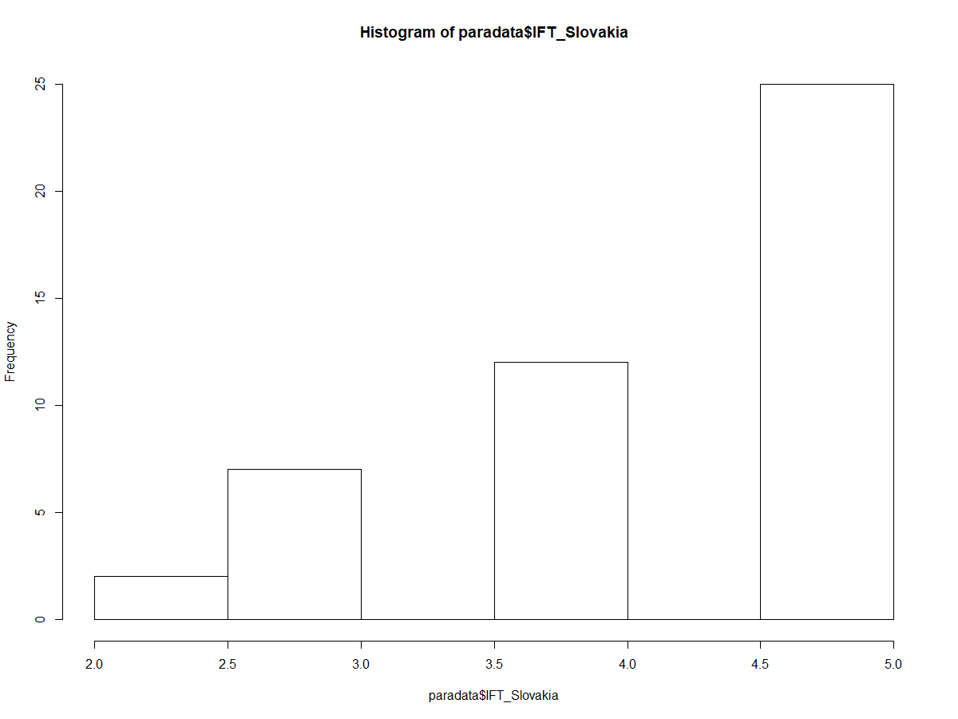

# Fusion to other members of Slovensky Brani

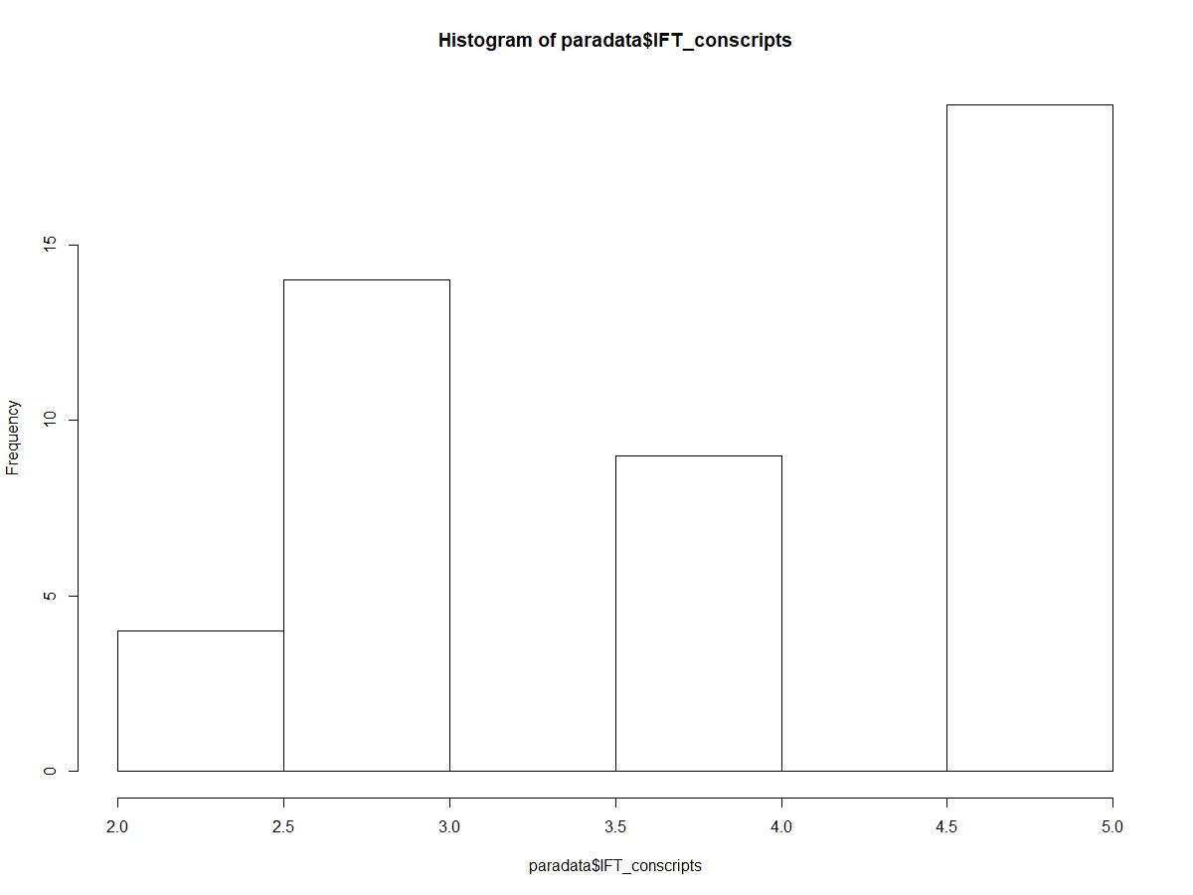

# Big-5 Personality

|  |  |
| --- | --- |
|  | Average (Mean) |
| Openness | 3.94 |
| Conscientiousness | 3.73 |
| Extraversion | 3.56 |
| Agreeableness | 4.15 |
| Neuroticism | 2.61 |